**SERIAL MONITOR CODE FOR BLUETOOH**

String a;

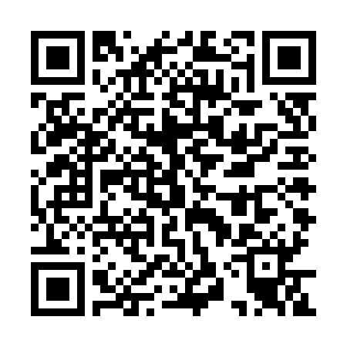

void setup() {

Serial.begin(9600);

}

void loop() {

while(Serial.available()) {

a= Serial.readString();

Serial.println(a);

}

}

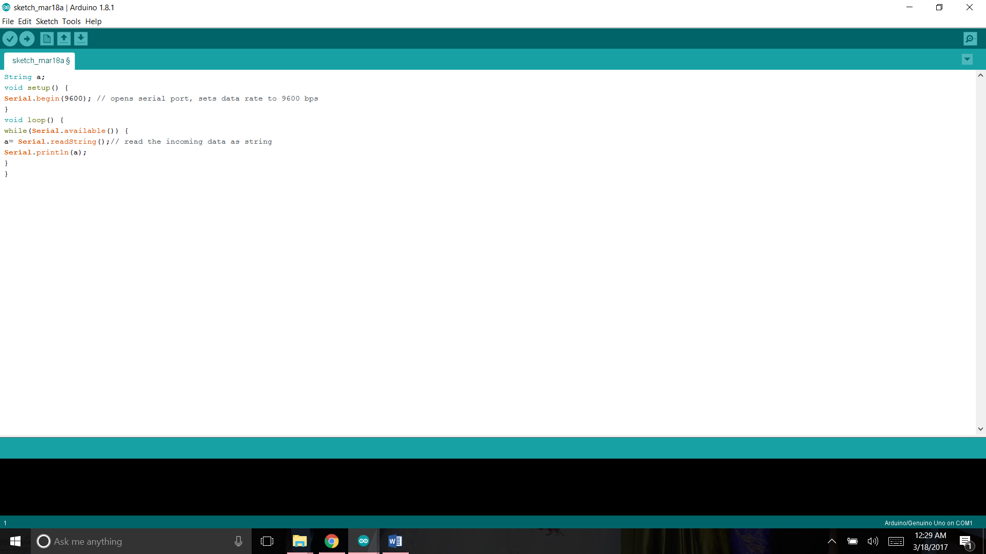

<https://raw.githubusercontent.com/Joneskys/PROGRAMS/master/SERIAL_TESTING_CODE.ino>

**BLUETOOH REMOTE CAR**

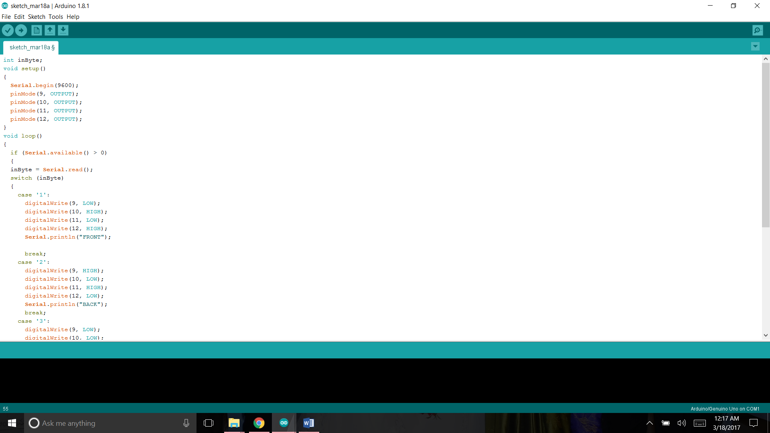­­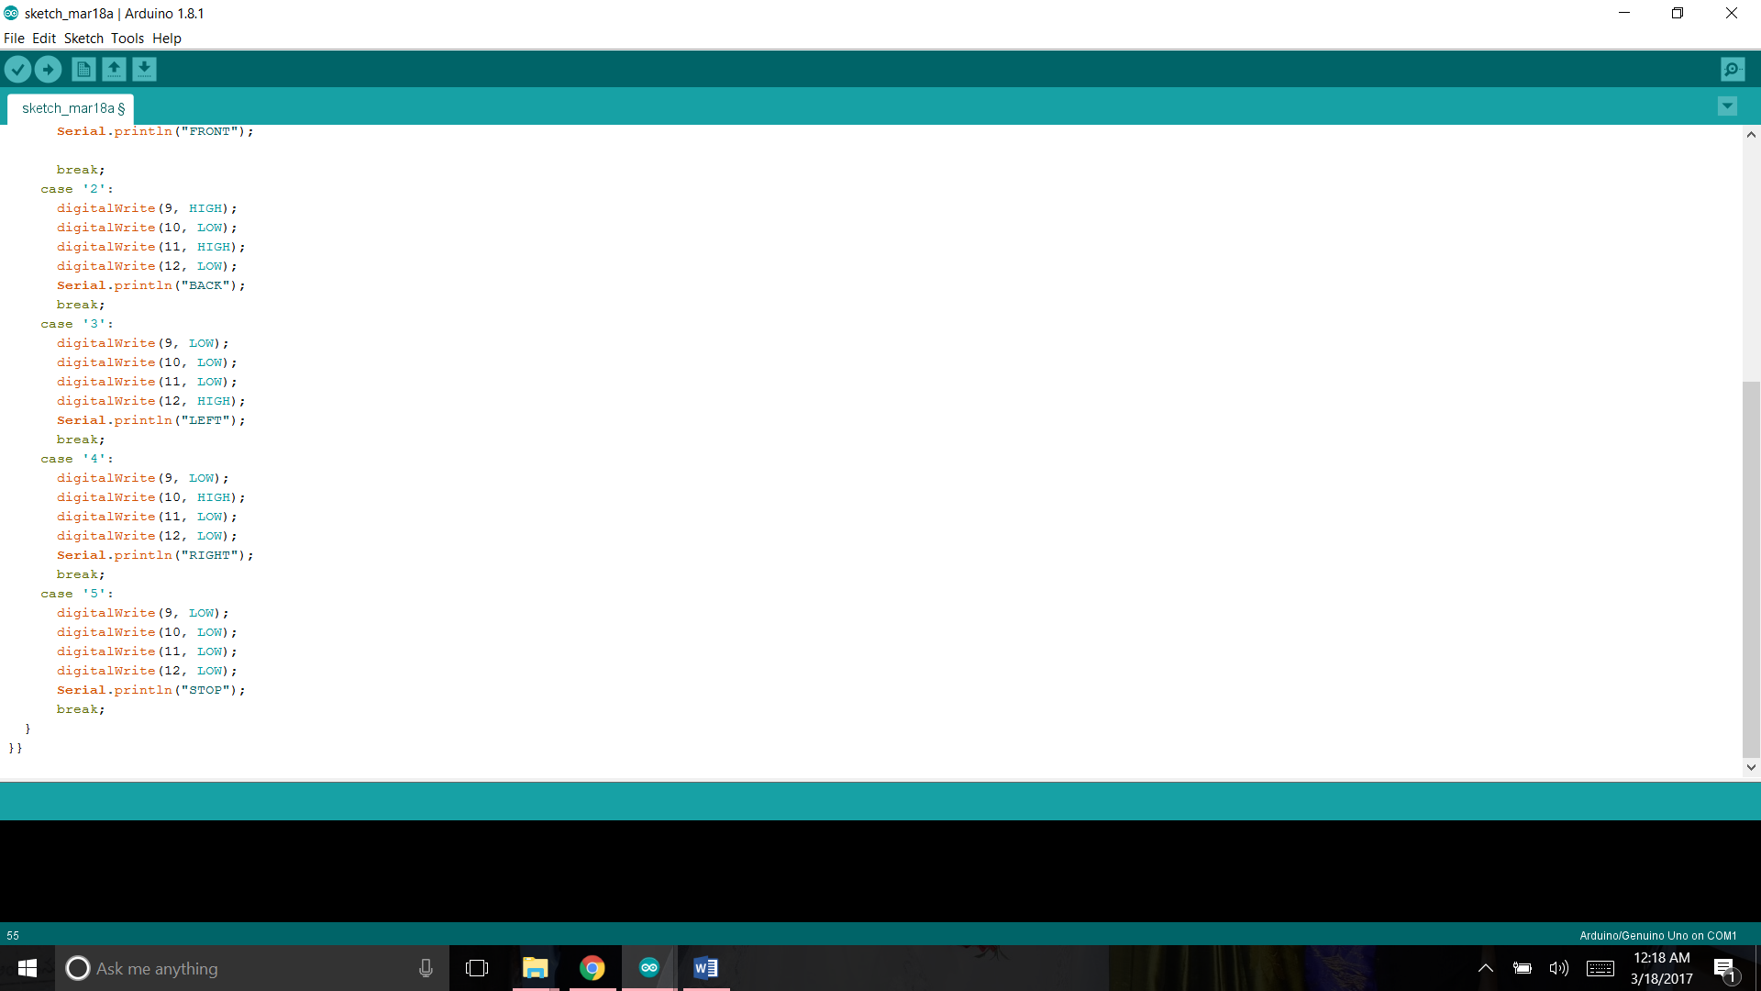

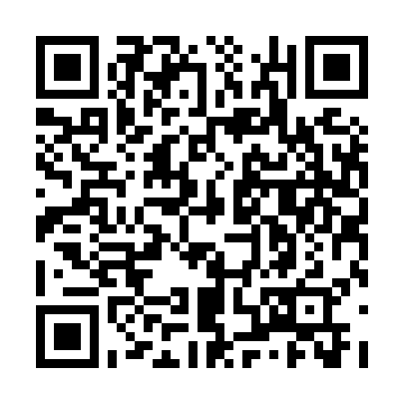

<https://raw.githubusercontent.com/Joneskys/PROGRAMS/master/BLUETOOTH_REMOTE_CAR.ino>